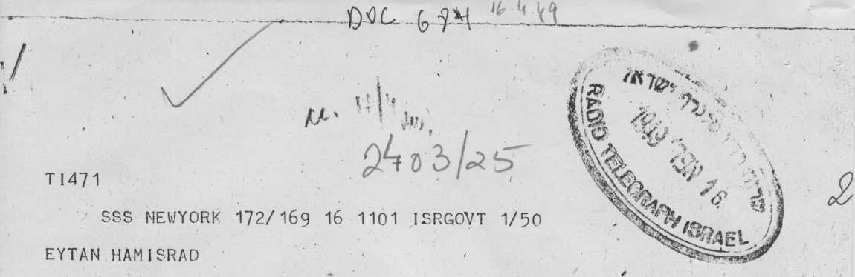
MS 10 SUGGEST FOLLOWING COMMUNICATION BE ADDRESSED PCC COLON DURING DEBATE IN ASSEMBLY ON SC RECOMMENDATION FOR ADMISSION ISRAEL MEMBERSHIP UN ISSUES WERE RAISED WHICH FORM SUBJECT
I • " ¹ , ־ • י־.',־. ■_ ־
COMMISSIONS MEDIATION SUCH AS REFUGEES AND JERUSALEM STOP
1
ALTHOUGH ON STRICT INTERPRETATION UN RULES AND RESOLUTIONS •' RAISING SUCH ISSUES CONNECTION ADMISSION
TELAV1V,

MS 10 PCC UN
T 147 1 PAGE 2/47 ׳
MEMBERSHIP WOULD APPEAR INADMISSIBLE COMMA ACTUAL COURSE DISCUSSION IN ASSEMBLY LEAVES LITTLE DOUBT THESE MATTERS WILL FORM SUBJECT DISCUSSION IN POLITICAL COMMITTEE WHEN ISRAELS APPLICATION IS CONSIDERED AND MEM ISRAEL MAYBE INVITED OR MAY ITSELF FIND NECESSARY DEFINE ITS ATTITUDE STOP MEM ISRAEL TRUSTS CC
\ ’
WILL AGREE WOULD BE

משרד החוץ

המנהל הכללי
|| ף* י־) יי״ ״ *Hirr ;
A
T1471 PAGE 3/5V50 '
HIGHLY INEXPEDIENT FOR MEM ISRAEL AND NOT IN INTERESTS CAUSE
' ' י'.-'■•• . ׳ \ ’ ' \ ' ' :
PEACE ITSELF IF SIMULTANEOUS DISCUSSION SAME SUBJECTS WAS TO PROCEED TWO DIFFERENT CONTACTS NAMELY POLITCOM CONNECTION ADMISSION
I
AND PEACE CONFERENCE SUBAUSPICIES CC LEADING CONFUSION AND POSSIBLY CROSS PURPOSES STOP THEREFORE MEM ISRAEL CONSIDERS ADVISABLE PEACE TALKS LAUZANNE BE POSTPONED TILL TERMINATION DISCUSSION
V . /
) . _{י} - ־
־ ,, . י ־ . , I
׳ ' •; ״ ־־ I
471 PAGE 4/22/20

V ׳
P °LITCOM OR TILL BECOMES CLEAR POLITCOM UN INTENDS PARALLEL CONSIDERATION ABOVE PROBLEMS COMMUNICATION ENDS CABLING
' • . . . j •
FURTHER SEPARATELY STOP CABLE ACTION ^{r}
. .. ■ ■ ו
־ ׳ « , SHARETT

